### **Creating a new certificate template for AD certificates.**

**1]** Click Start > Run and type **certtmpl.msc** and click OK. This starts up the Certificates Templates Console. We’ll be creating a new template for use by the users to connect to OpenVpn.. Let’s configure the template.

In the Certificate Template Console, under Template Display Name, right-click **User** and click **Duplicate Template**.

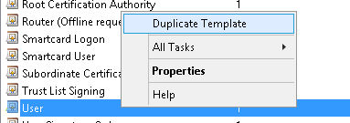

**2]** In the Duplicate Template window, select **Windows Server 2003 Enterprise** for backward compatibility.

*Notes:*

1. *The UI may not show “****Windows Server 2003 Enterprise****” unless you are running an Enterprise edition of Windows. Select “****Windows 2003****” as seen below.*
2. *If you have an encryption level higher than SHA1, select* ***Windows Server 2008 Enterprise or higher****.*

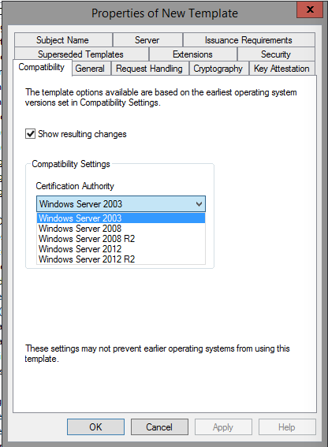

***3]*** *Click the General tab. In the Template display name field, enter* ***VpnUsers*** *as the name of the new template and select* ***Public certificate in Active Directory.***

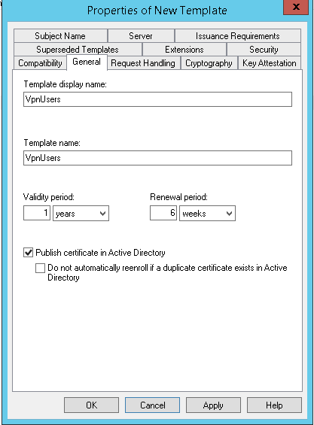

***4]*** *Click the Request Handling tab. Select options as below****.***

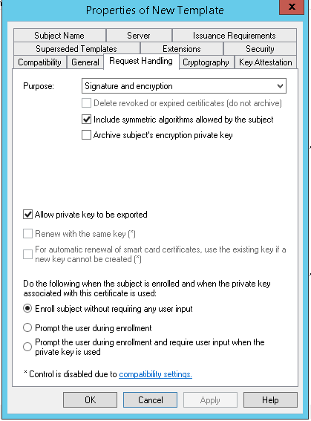

***5]*** *Click the Subject Name tab. Select Subject name format* ***Fully distinguished name*** *and tick only* ***User principal name*** *and* ***Service principal name.***

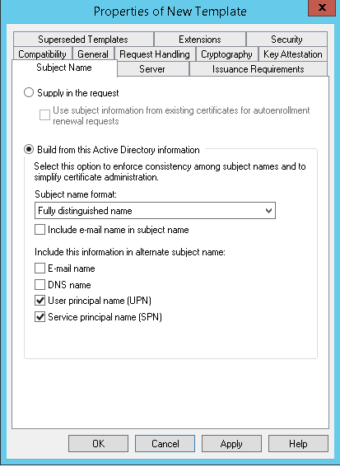

***6]*** *Click the Security tab. Add* ***Domain Users*** *group then tick* ***Read, Enroll*** *and* ***Autoenroll*** *in Allow list then do same for* ***Authenticates Users*** *group then click on*  ***Apply then OK****.*

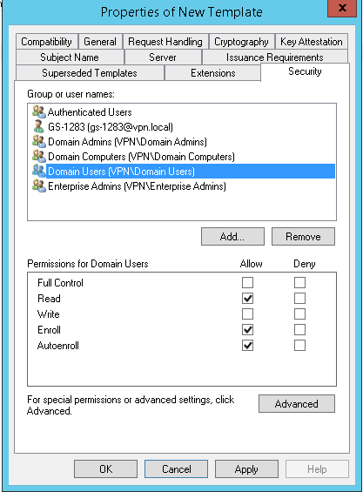

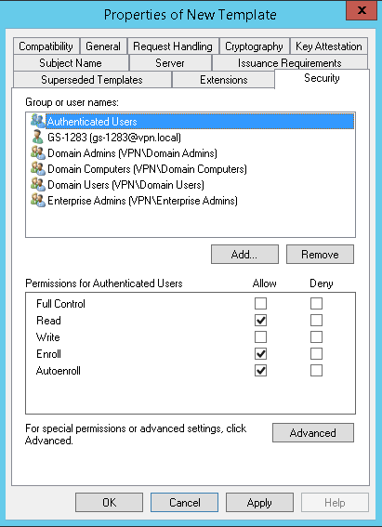

***6]*** *Click the* ***Extensions*** *tab then* ***edit*** *then new in Edit application Policies extension windows click on add then select* ***Server Authentication*** *then click* ***OK****.*

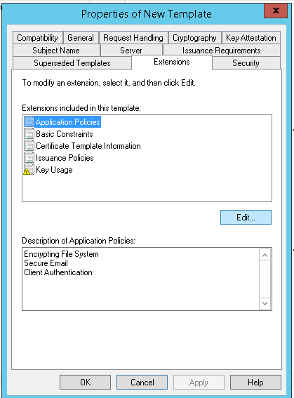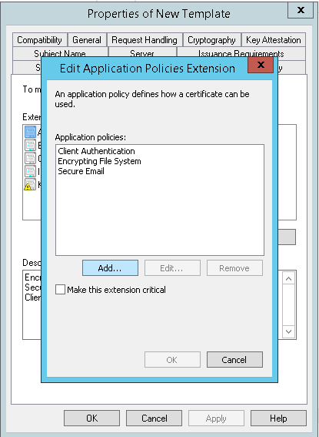

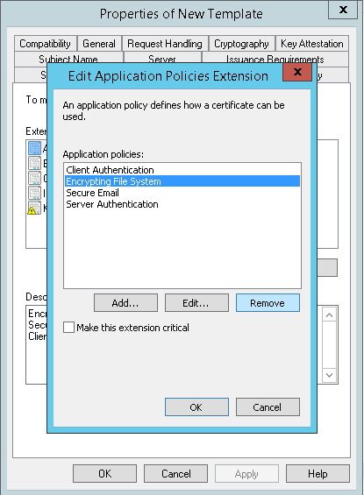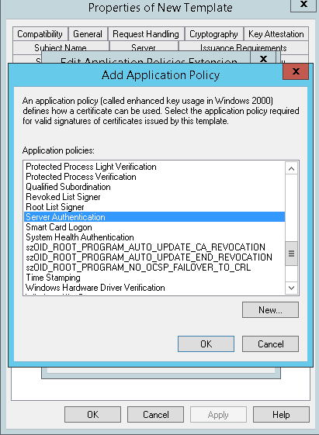

*After adding* ***Server Authentication*** *click on* ***OK*** *then click on* ***Apply*** *then* ***OK****.*

***7]*** *In template list now you can see* ***VpnUsers*** *template.*

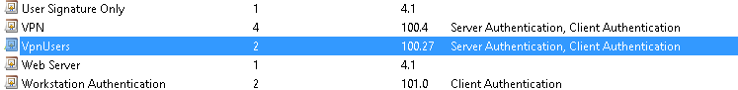

***8]*** *Open* ***Server Manager*** *in tools click on* ***Certification Authority****.*

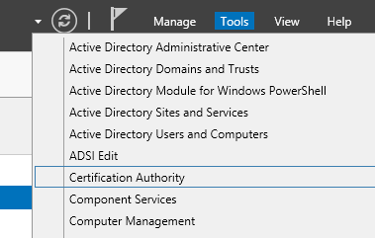

***9]*** *In your CA right click on* ***Certificate template*** *then* ***New > Certificate Template to Issue****.*

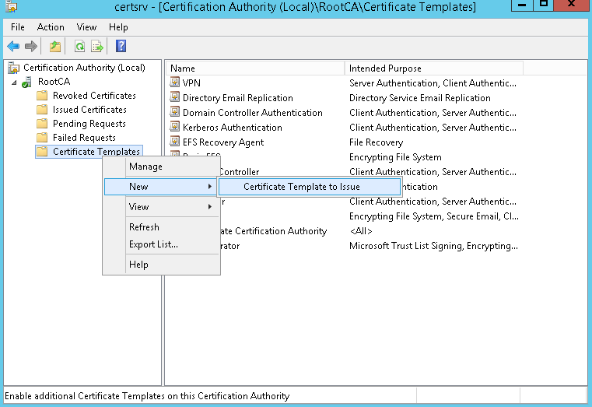

***10]*** *Select the certificate template we created previously* ***“VpnUsers”*** *then click* ***OK****.*

